CS795 Vertex AI Assignment 1
Anton Rasmussen
Fall 2025

I attempted to train a simple machine learning model, deploying it to Google Cloud's Vertex AI, and using the deployed model for predictions.
Objective: The primary goal of this exercise was to demonstrate a basic end-to-end MLOps workflow using Vertex AI. This involved:
- Training a scikit-learn model locally.
- Uploading the model to the Vertex AI Model Registry.
- Deploying the model to a live endpoint for online predictions.
- Executing both online (real-time) and batch prediction jobs.
Process Summary: A RandomForestClassifier was trained on the Iris dataset and saved locally. The model artifact was then uploaded to the Vertex AI Model Registry, using a pre-built serving container. An endpoint was created, and the model was supposed to be deployed to it, making it available to serve prediction requests.
However, I kept running into errors and because I do not have access to logging via Log Explorer I am unsure how to resolve this--I believe it may be a permissions issue. I have submitted a request for IAM access to Google Cloud Logging.

First I tried to do it locally but I was getting the following issues:
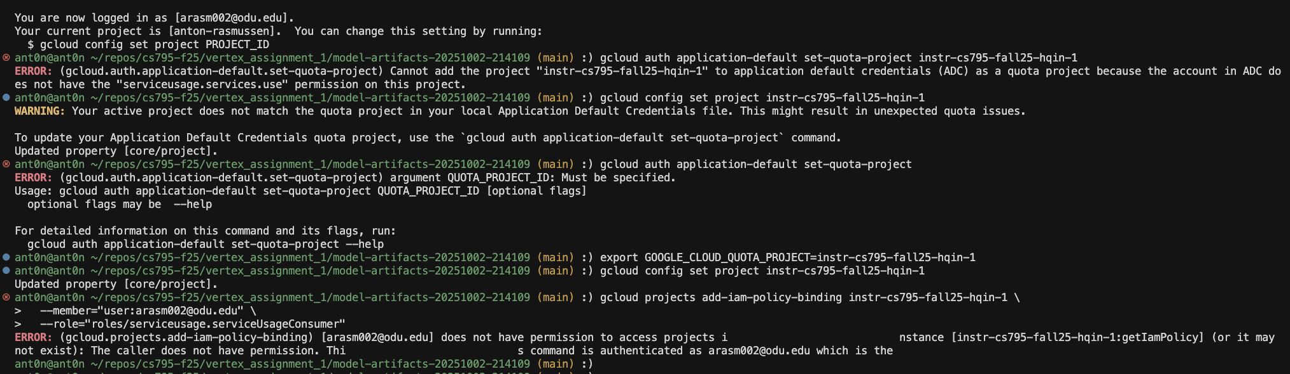
Then I created a Collab Notebook but still kept getting stuck at the same point (the part where I deploy the model):
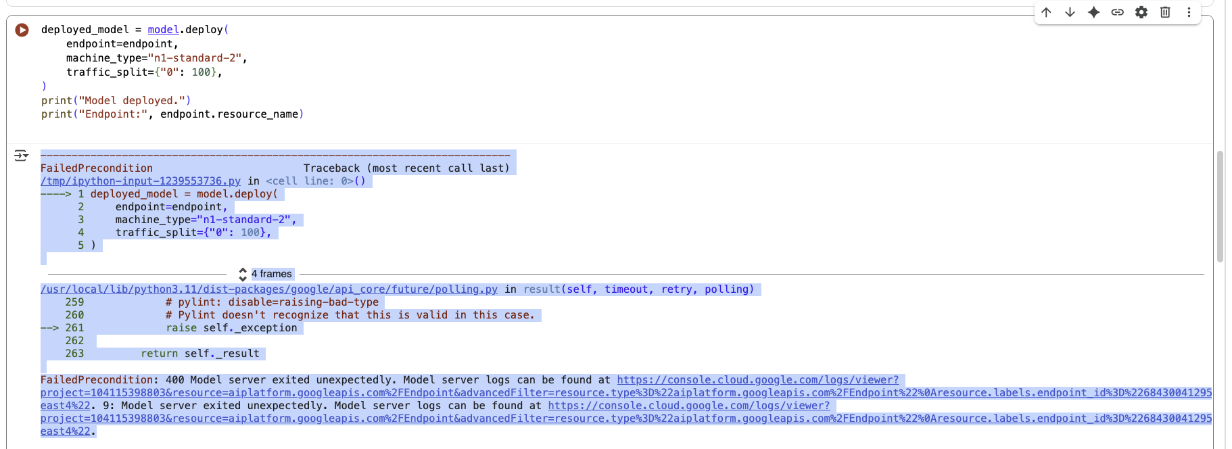

Here is a link to my notebook:
https://console.cloud.google.com/vertex-ai/colab/notebooks?authuser=1&project=instr-cs795-fall25-hqin-1&activeNb=projects%2Finstr-cs795-fall25-hqin-1%2Flocations%2Fus-central1%2Frepositories%2F607a41f8-9319-4308-a2ef-1102c0b0a6e2

Follow Up Actions:
0) I will continue working with Gemini to see if there’s another way to do this with my current permissions (frustrating, but hopefully I can find a solution).
1) I will reach out to Terry to see if he can enable this role:
roles/serviceusage.serviceUsageConsumer

2) If need be for my project, I’ll just use my own GCP instance

